Independent Software Vendors HTC Usage Primer
V0.1 – May 8th 2008

Motivation
ISVs wish to integrate their desktop applications residing on client workstations with ‘back-end’ compute resources in a uniform or standard manner. This may consist of both connected and disconnected clients, and may involve file movement between clients, the compute back-end, and third party data servers. In addition there are issues arising from firewalls, NATS, and other networking impediments that exist in the real world. In other words, the client workstation, and/or compute backend, may not have globally addressable IP addresses.

The generic physical infrastructure is described below:
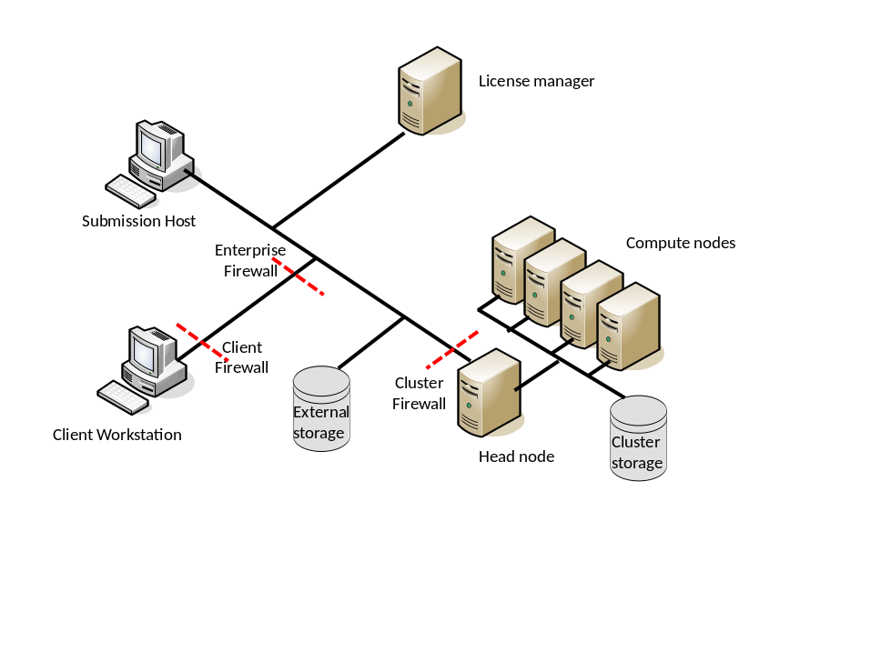

Actors
Here we define the important characteristics of the actors/players in the diagrams.

- Client workstation: The machine used by the end-user to submit, monitor and retrieve their results.
- Submission hosts: Workstations from which the user can submit and monitor jobs to the compute cluster.
- The back-end compute resource, consisting of:
  - Head node: This is the primary contact point for submission hosts to submit work to the cluster. Possibly the only part of the compute resource visible to other network clients.
  - Compute nodes: The compute resources managed by the head node. These nodes may only be accessible from the Head node.
  - A “cluster” file system that is common between the head node and compute nodes.
- Globally accessible (subject to access control) file storage space: Storage space that can be accessed over the network from the client workstation, submission host or the head node.
- Network Router: Linking the workstation, submission hosts and head nodes.
- Firewall(s): One of many protecting the head node, client workstation and submission hosts.

Additional constraints
The goal in this scenario is to provide a ‘good’ user experience when the client machine is in ‘difficult’ networking environments. Specifically:
- There is no shared file system between the client and the cluster’s head node. Depending on the scheduling system this may make it impossible for the client workstation to act as a submission host to the scheduler, and for the computational task to access the files located on the client workstation.
- Many computational applications have an element of interaction with the compute nodes. In such a scenario the compute nodes need to be able to ‘connect back’ to the client workstation to provide interim results.
- Disconnected operation. It cannot be assumed that an application on the client will always be connected to the network during the complete life-cycle of any batch job. This of particular concern for long running analysis.
- Any solution must leverage the existing security mechanisms available on the client workstation and available within the enterprise. Bespoke security solutions should not be embedded within the ISV application.
- Others…

What we are not worrying about right now
In these scenarios we are realistic simplifications to provide a still useful solution. In particular:
- We are not concerning ourselves with the process by which a client application finds a compute resource. We assume that such a resource is ‘well known’ within an organization and such a resource may encapsulate other resources… but if it does such behavior is not visible to the client application.
- Others…

Scenario’s
In this section we will describe the two main motivating scenarios driving ISVs in the HTC scenarios:
- Direct job submission from a client workstation to a back-end compute cluster.
- Direct job submission from a client workstation to a back-end in which the compute nodes need to “connect” back to the client workstation, e.g. to deliver interim results.

In these scenarios we will assume:
- There is no shared file system between the client workstation and the compute cluster thereby requiring some form of file staging to take place both of input data and the final results.
- The client workstation may not have an IP address that can be accessed by the compute cluster, thereby making it impossible for the computer cluster to access a service running the client workstation that can provide/receive files from the compute cluster.
- The client workstation may not be available throughout the job’s complete life-cycle (i.e. submission, queuing and execution) as it has disconnected.

The software infrastructure to support these scenarios includes:
- Client operating system
- Cluster operating system
- Cluster’s job scheduling software
- Application – client component
- Application – cluster component
- Client middleware – installed or incorporated into the application’s client component
- Server middleware – installed or incorporated into the software running on the head node
- File server software

Installation and Configuration
Server
The cluster administrator needs to perform a one off installation and configuration of the ‘middleware’ software. It is assumed that the base operating system and cluster software are already installed – administrators will resist having to change this infrastructure. This is the non-application specific software necessary to connect the client to the cluster scheduler and the application. Software from different applications will also need to be installed on cluster.

Client
The administrator of the client machine will need to install the client components of the application software and any middleware software need to support the client interactions. This software needs to install on top of the existing operating system components.

Verification
Several verification steps can be identified on both the cluster and the client machine before any of these scenarios should be attempted:
- Run the application on the cluster from the cluster:
  - On a single processor.
  - On multiple processors as part of a parallel (MPI) job.
- Upload a file from the head node to the remote file store.
- Download a file from the remote file store to the head node.
- Upload a file from a compute node to the remote file store.
  - This may not be supported by the cluster if compute nodes have no external network visibility.
- Download a file from the remote file store to a compute node.
  - This may not be supported by the cluster if compute nodes have no external network visibility.
- Upload a file from the client machine to the remote file store.
- Download a file from the remote file store to the client machine.
- Upload a file from the client machine to the cluster’s head node.
- Download a file from the cluster’s head node to the client machine.
- That there is network connectivity from the client machine to the cluster.
- The credentials provided by the user on the client machine can access the service on the head node.
- The credentials provided by the user on the client machine can access and submit a job through the service on the head node to the cluster.

Running through these tests, both on installation and during use, provides the means to self-configure the client to adapt to its current network environment, and the means to trouble shoot any failures.

Direct Job Submission
With the middleware and application software installed on the client and the cluster and the connectivity between the components verified, the remote execution of the application can be initiated:

- Interaction between the user with the client application to formulate the problem that needs to be solved on the remote resource.
- Identification and generation of any configuration or data files needed by the application when it is executed on the remote resource.
- Selection of a cluster that is to be used to solve the problem:
  - The required application needs to be installed on the selected cluster
  - The user needs to have credentials to access the cluster
  - The client machine is able to contact the cluster
  - The client machine and the cluster are able to transfer files between each other or through a remote file store if required by the analysis.
- Formulation of the JSDL document using:
  - HPC Application profile if a single processor job
  - JSDL-SPMD if a multi-processor job
  - JSDL-Parameter Sweep specification if a parameter sweep job
- Uploading of the files to the designated file server if required.
- Submission of the JSDL document to the cluster’s HPCBP endpoint.
The client may disconnect from the network at this point.

- Downloading of the files to the cluster from the file server.
- Execution of the application.
- Uploading of any output files to the designated file server.

The client either:
- Has remained connected to the network and recognizes through polling that the activity is complete.
- Reconnects to the network and realizes that the activities it has dispatched are complete.

Execution on the client continues:
- Retrieval of the output files from the designated file server to the client.
- Notification (locally) to the user that the job is complete.

There is no requirement that the client is directly addressable by the cluster or a need for a shared file system.

Direct Job Submission with interim results from the compute nodes
With the middleware and application software installed on the client and the cluster and the connectivity between the components verified, the remote execution of the application can be initiated. In this scenario the client needs to remain connected to receive interim results from the application.

- Interaction between the user with the client application to formulate the problem that needs to be solved on the remote resource.
- Identification and generation of any configuration or data files needed by the application when it is executed on the remote resource.
- Selection of a cluster that is to be used to solve the problem:
  - The required application needs to be installed on the selected cluster
  - The user needs to have credentials to access the cluster
  - The client machine is able to contact the cluster
  - The client machine and the cluster are able to transfer files between each other or through a remote file store if required by the analysis.
- Initialization of a ByteIO endpoint on the cluster’s head node.
- Formulation of the JSDL document with the ByteIO endpoint:
  - HPC Application profile if a single processor job
  - JSDL-SPMD if a multi-processor job
  - JSDL-Parameter Sweep specification if a parameter sweep job
- Uploading of the files to the designated file server if required.
- Submission of the JSDL document to the cluster’s HPCBP endpoint.

Activity on the cluster and on the client takes place concurrently:

On the cluster | On the client machine
- Downloading of the files to the cluster from the file server. | Retrieve interim results from the ByteIO endpoint and act on them.
- Initialization of the application.
- Delivery of interim results to the ByteIO endpoint on the head node.
- Completion of the application.
- Uploading of any output files to the designated file server. | Poll the activity until it is compelte.

Execution on the client continues:
- Retrieval of the output files from the designated file server to the client.
- Notification (locally) to the user that the job is complete.

There is no requirement that the client is directly addressable by the cluster or a need for a shared file system. The application needs to be modified to deliver interim output to the ByteIO endpoint.

Specification Pool
BES
JSDL
HPC BP
FS Extension of HPC-BP
HPCP-Application
JSDL-SPMD
OGSA-ByteIO (streamable and possible standard)
WS-Security
WS-Addressing
WSI 1.0 BSP

Need to know the “native” credentialing mechanism is, username/password, X.509, where they are stored, how to get to them, and then how to shove them into the SOAP headers. This is going to be an ISV problem.

Question to ISV’s – what sort of credentials are you using to authenticate to back-end compute clusters

Realization using Specs and Profiles
We describe for each scenario how the above specs and profiles can be used to implement the spec – this will include a sequence “diagram” or list of steps.

Advice to ISV’s

Advice to Platform Providers

Question to the ISVs, do you want a toolkit to access the porttypes on a BES?
Or ftp/scp/http server with one time passwords call-back
OR setting up streaming sockets

Next steps:
Need to enhance with security domains/policy issue.
Fill out scenario and complicating conditions
Fill out sequencing in words
Updated document by middle of May
Have the SDK debate
How does SAGA/DRMAA fit in?
What is the form of the “Globally accessilbe file storage”
Read out of this document to the use case workshop
OGSA session to continue discussing the updated document

TO BE CUT:

What is the problem?
Why is it important? (Who cares)
What is the shape of the solution?
Why is this solution better than others? (related work)

